Plan Sponsor Information
Sponsor Name | Google Llc
Sponsor Contacts | Daniel Marafino
Sponsor EIN | 77-0493581
Sponsor Address | 1600 Amphitheatre Parkway
Sponsor City | Mountain View
Sponsor State | CA
Sponsor Zip | 94043-1351
Sponsor Phone | 650-623-4000
Sponsor Type | Single
Plan Business Code | 519100*
*Other Information Services (including news syndicates, libraries, internet publishing & broadcasting)

General Plan Information
Plan Name | Google Llc 401(K) Savings Plan
Plan Number | 001
Plan Effective Date | 1999-01-01
Plan Year | 2018-01-01 to 2018-12-31
Plan Type | DC
Plan Sub Type | Profit Sharing
Total Participants | 83,353
Active Participants | 70,036
Total Assets | 11,786,824,293

Plan Characteristics
Cross Tested Plan | No | ALERT
DB Offset Plan | No
Complies with DOL sec 404(c) | Yes
Participant Self Direction | Total
401(k) Plan | Yes
Matching Contributions | Yes
Plan Loans Allowed | Yes | ALERT
Plan Allows Brokerage Accounts | Yes | ALERT
Default Investment Accounts | Yes
Auto Enrollment | Yes
Plan is Non Qualified | No
Plan Uses Pre Approved Documents | No | ALERT
Puerto Rico Dual Qualified | No
Plan Invests in Employer Securities | No
Plan Covers Self Employed | No
One Participant Plan | No
Plan Covers Leased Employees | Yes
Sponsor is Part of Controlled Group | No

Plan Compliance Information
Bond Coverage Level | OK
Failed to Transmit Contributions When Due | OK
Loss Discovered During Year | OK
Terminated Plan | OK
Delinquent Filer Program | OK
Prohibited Transactions | OK
Failed to Provide a Benefit When Due | OK
Failed to Comply With Blackout Notice | OK
Provider Failed to Provide Sch C Information | OK

Plan Financial/Operational Metrics
Total Participants | 83,353
Active Participants | 70,036
Three Year Participant Growth | 20.57%
Plan Assets | 11,786,824,293
Three Year Asset Growth | 34.44%
Participants with Balance | 82,725
Total Corrective/Deemed Distributions | 480,259
Percent of Assets Invested in Cash | 0%
Investment Income | -880,153,206
Administrative Exp | 1,401,876
Curent Investment Return | -7.79%
Administrative Expense Per Participant | 16
Average Participant Contribution | 19,142
Average Employer Contribution | 7,788
Participation Rate | 99
Average Account Balance | 141,408
Distributions Per Participant | 4,232
Corrective/Deemed Distributions Per Participant | 6
Percentage of Terminated Participants | 16%

Plan Financial/Operational Graphs
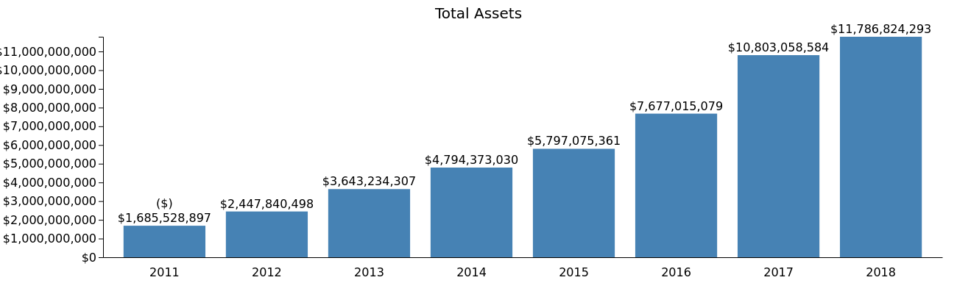
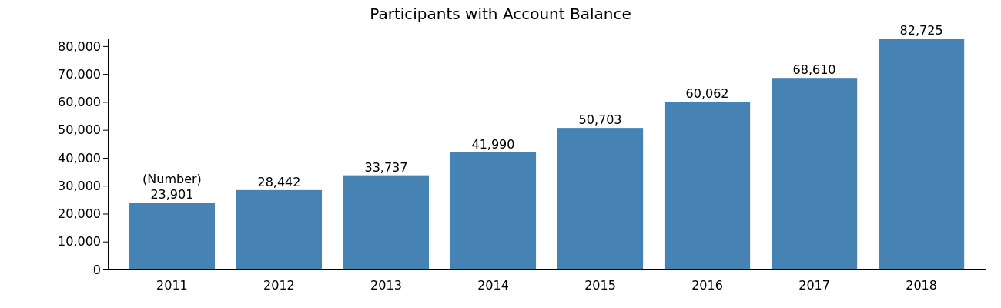
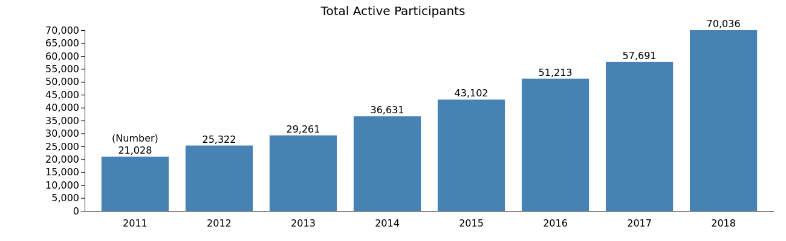
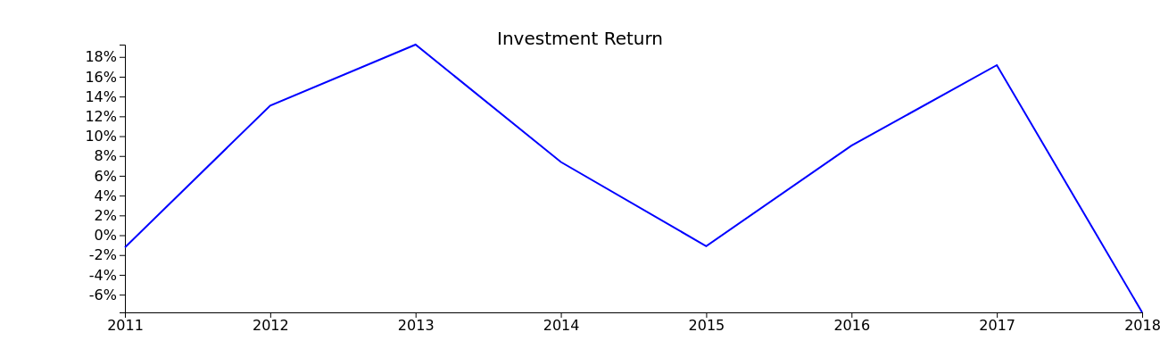
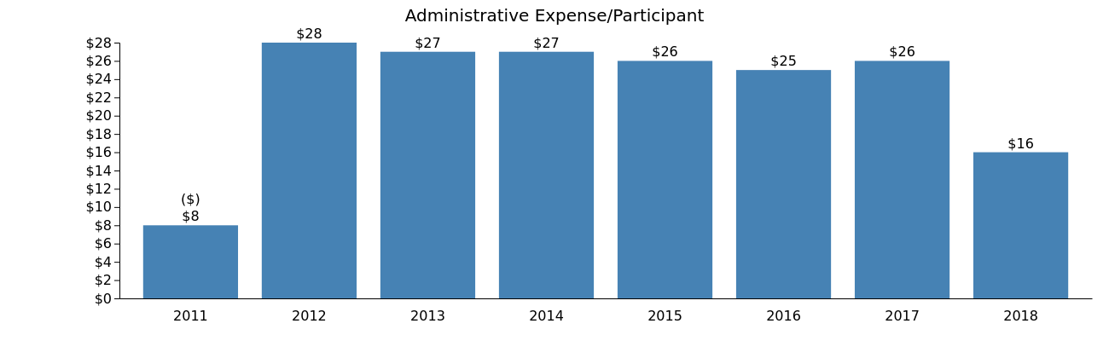
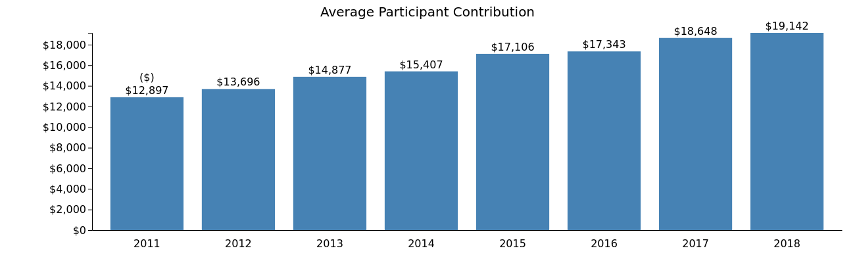
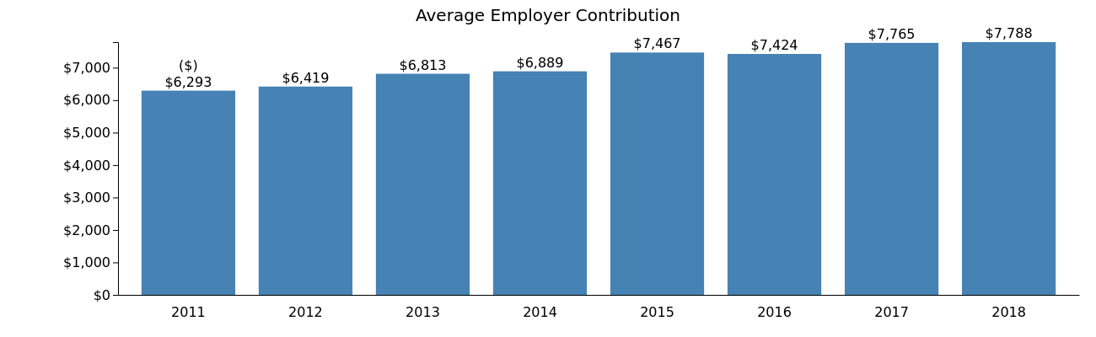
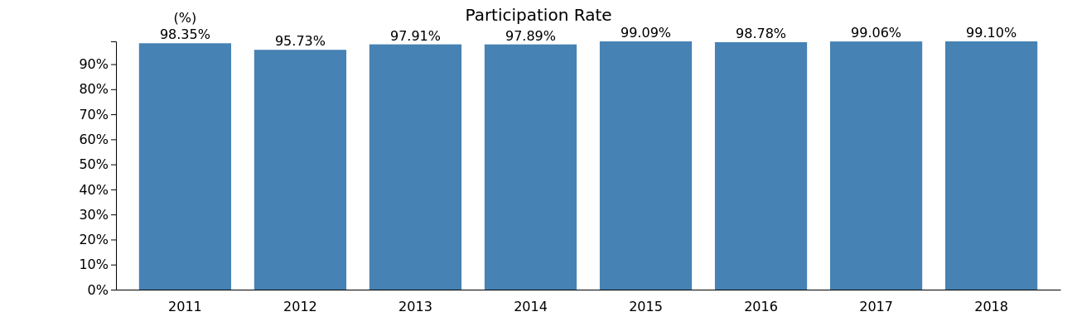
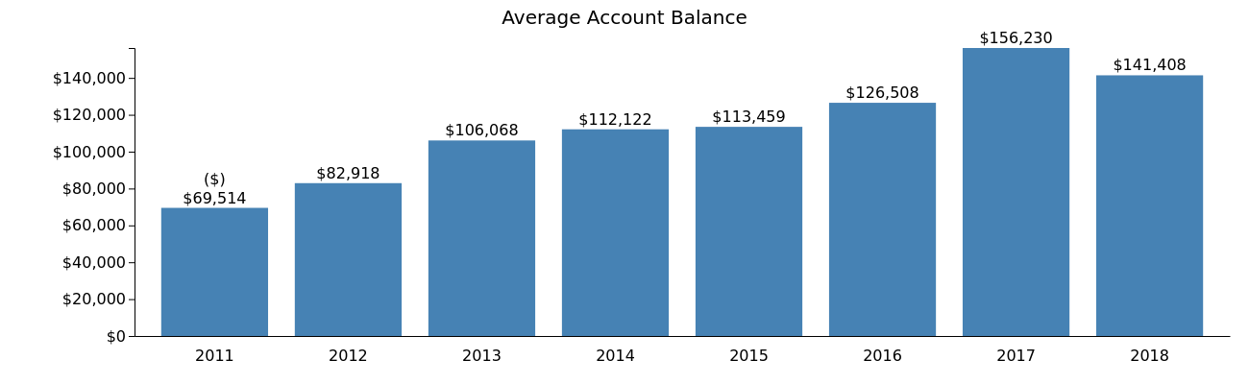
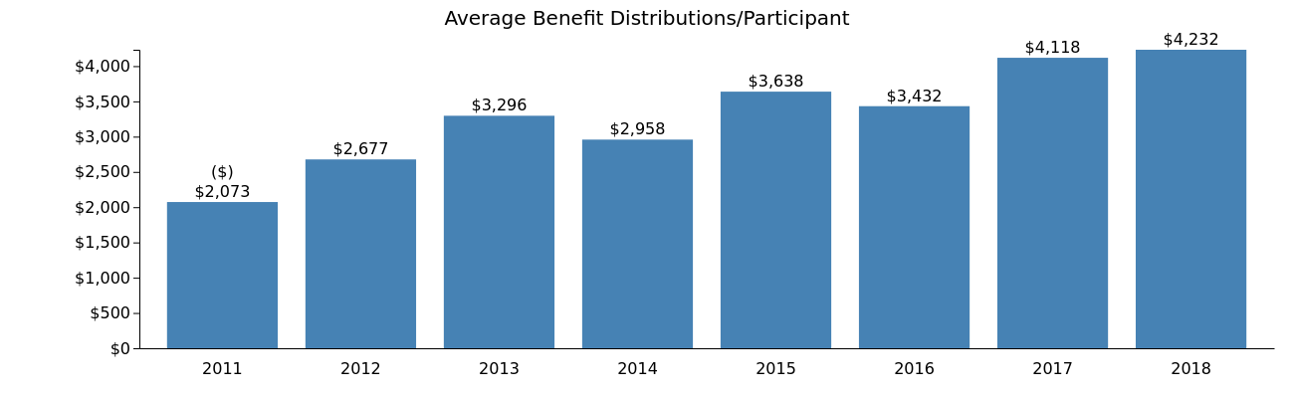
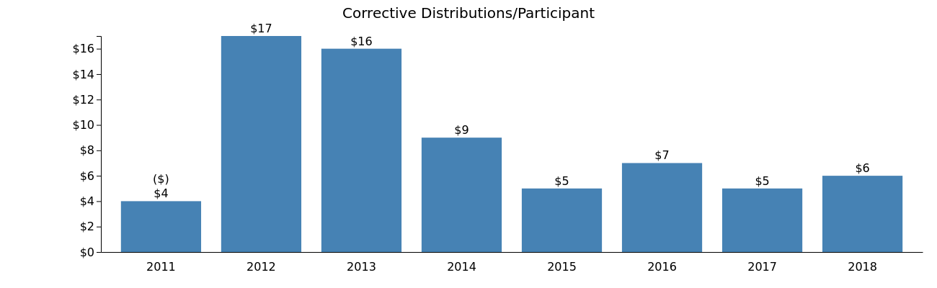
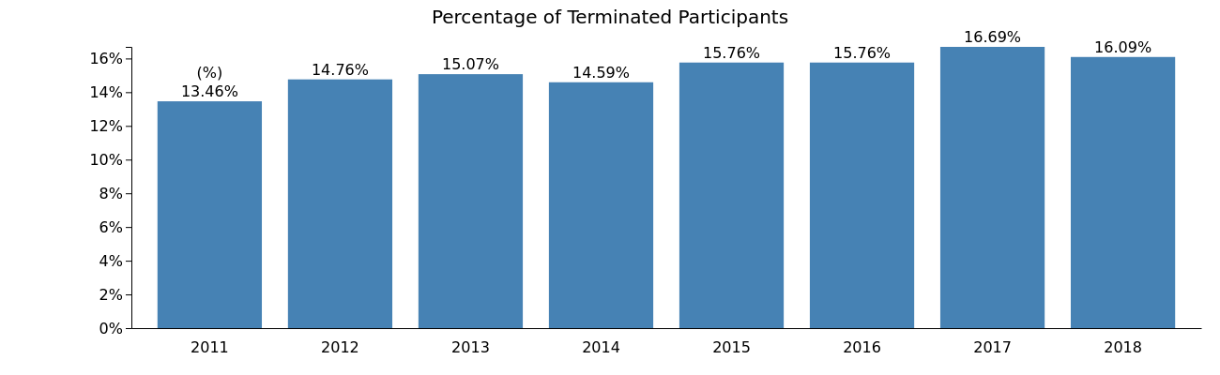

Plan Service Providers
Provider Name | Source | Amount | Codes | Explanation
Crowe Llp | Auditor | 0 | N/A
Dodge & Cox | SchC | 0 | N/A | 10 BPS
The Vanguard Group, Inc. | SchC | 1,434,851 | 15-Recordkeeping and information management  16-Consulting (general)  25-Trustee (directed)  26-Investment advisory (participants)  37-Participant loan processing  52-Investment management fees paid indirectly by plan
The Vanguard Group, Inc. | SchC | 0 | 64-Recordkeeping fees | 10 BPS
The Vanguard Group, Inc. | SchC | 0 | N/A
Vanguard Fiduciary Trust Company | SchD | 32,665,193 | N/A | C-Vftc Target Ret Income Trust Select
Vanguard Fiduciary Trust Company | SchD | 574,661,662 | N/A | C-Vftc Inst. Ext. Market Index Trust
Vanguard Fiduciary Trust Company | SchD | 1,642,593,702 | N/A | C-Vftc Target Ret 2045 Trust Select
Vanguard Fiduciary Trust Company | SchD | 265,640,713 | N/A | C-Vanguard Ret Savings Trust Ii
Vanguard Fiduciary Trust Company | SchD | 646,486,944 | N/A | C-Vftc Target Ret 2035 Trust Select
Vanguard Fiduciary Trust Company | SchD | 272,467,104 | N/A | C-Vftc Target Ret 2060 Trust Select
Vanguard Fiduciary Trust Company | SchD | 1,706,979,492 | N/A | C-Vftc Target Ret 2050 Trust Select
Vanguard Fiduciary Trust Company | SchD | 1,264,171,594 | N/A | C-Vftc Institutional 500 Index Trust
Vanguard Fiduciary Trust Company | SchD | 31,672,977 | N/A | C-Vftc Target Ret 2015 Trust Select
Vanguard Fiduciary Trust Company | SchD | 1,057,657,349 | N/A | C-Vftc Target Ret 2040 Trust Select
Vanguard Fiduciary Trust Company | SchD | 422,160,759 | N/A | C-Vftc Inst'L Total Bond Mkt Index Tr
Vanguard Fiduciary Trust Company | SchD | 178,827,713 | N/A | C-Vftc Target Ret 2025 Trust Select
Vanguard Fiduciary Trust Company | SchD | 90,755,746 | N/A | C-Vftc Target Ret 2020 Trust Select
Vanguard Fiduciary Trust Company | SchD | 1,083,900,481 | N/A | C-Vftc Target Ret 2055 Trust Select
Vanguard Fiduciary Trust Company | SchD | 9,120,300 | N/A | C-Vftc Target Ret 2065 Trust Select
Vanguard Fiduciary Trust Company | SchD | 389,153,510 | N/A | C-Vftc Target Ret 2030 Trust Select
William Blair & Co. Ii | SchD | 62,308,033 | N/A | C-William Blair Small Mid Growth

All Plans Maintained by Sponsor
Year | Plan Name | Type | Participants | Assets
2018 | Google Llc 401(K) Savings Plan | DC | 83,353 | 11,786,824,293
2018 | Google Inc. Severance Plan | WF | 68,608 | 0
2018 | Google Llc Welfare Benefit Plan | WF | 69,147 | 0
2018 | Ads Next, Llc 401(K) Plan | DC | 11 | 147,156

