Google Llc
Google Llc 401(K) Savings Plan
Plan Summary

Plan Overall Operational Score  Scores Range from 0 to 100 with 100 being a perfect score.  Benchmark Peer Group  Peer Group Business Category Information and Publishing  Peer Group Size Over 5,000 Participants  Plans in Peer Group 69 | Plan Sponsor Information  Sponsor Name Google Llc  Sponsor Contacts Daniel Marafino  Sponsor EIN 77-0493581  Sponsor Address 1600 Amphitheatre Parkway  Sponsor City Mountain View  Sponsor State CA  Sponsor Zip 94043-1351  Sponsor Phone 650-623-4000  Sponsor Type Single  Plan Business Code 519100*  *Other Information Services (including news syndicates, libraries, internet publishing & broadcasting)  General Plan Information  Plan Number 001  Plan Effective Date 1999-01-01  Plan Year 2018-01-01 to 2018-12-31  Plan Type DC  Plan Sub Type Profit Sharing  Total Participants 83,353  Active Participants 70,036  Total Assets 11,786,824,293  Detail Plan Information  401(k) Plan Yes  Matching Contributions Yes  Cross Tested Plan No  Complies with DOL sec 404(c) Yes  Participant Self-Direction Total  ESOP Maintained by Subchapter S No  Plan Allows Brokerage Accounts Yes  Auto Enrollment Yes  Default Investment Accounts Yes  Plan Invests in Empl Securities No  Sponsor is Part of Controlled Group No

Google Llc
Google Llc 401(K) Savings Plan
Operational Planning Opportunities

Plan Alerts - Benchmarks
Corrective Distributions/Participant | The plan has a high percentile score compared to its peer group. A high percentile score generally indicates failed non-discrimination tests and/or forfeiture of participant loans.
Investment Return | The plan has a low percentile score compared to its peer group. This is an indication that plan investments may need to be reviewed.

Plan Alerts - Planning Opportunities
Cross Tested Plan | The plan does not provide for cross-testing. A cross-tested plan may allow for older business owners to receive higher profit-sharing allocations as a percentage of compensation than other employees. This feature is generally most effective when business owners are older and enough other employees are younger.
Plan Allows Brokerage Accounts | The plan allows brokerage accounts. While this can be great feature for small owner-dominated plans, this feature can lead to higher expenses and compliance issues if the plan covers a number of non-owners.

Plan Alerts - Plan Status
Participant Loans | The plan allows participants to obtain loans from the plan. This feature can lead to higher expenses and compliance issues.

Google Llc
Google Llc 401(K) Savings Plan
Operational Benchmark Description

Plan Overall Operational Score  Scores Range from 0 to 100 with 100 being a perfect score. | Benchmark Peer Group  Peer Group Business Category Information and Publishing  Peer Group Size Over 5,000 Participants  Plans in Peer Group 69

How to Interpret the Benchmarking Data
Plan Overall Operational Score

The total overall operational benchmark score is a proprietary metric that takes into account most of the operational metrics described in this report. Scores Range from 0 to 100 with 100 being a perfect score.

Individual Operational Metrics

The benchmarking is performed using the plan's standard peer group. The standard peer group is determined using the business code entered for the plan sponsor and the number participants entered on the most recently filed Form 5500. The business codes are aggregated into 22 business categories. The business and plan size categories for the plan are summarized in the box above.

Each individual benchmark is represented by a percentile score of the plan versus its peer group. For most benchmarks, the higher the percentile, the better the performance. For example, if the Investment Return of the plan is at the 70th percentile, that means that 70% of the plans in the peer group performed worse than the plan and only 30% performed better. For the Administrative Expense/Participant, Corrective Distributions/Participant and Average Benefit Distributions/Participant metrics, the higher the percentile, the less favorable the performance. For example, if the Administrative Expense/Participant of the plan is at the 70th percentile, that means that 70% of the plans in the peer group had lower administrative expense per participant and only 30% had higher administrative expense per participant.

A red gauge means that the plan rates unfavorably versus the peer group. A yellow gauge indicates that plan is in the middle of the pack and a green gauge means that the plan rates favorably versus the peer group. In many cases, a red gauge indicates that corrective action may be warranted.

Google Llc
Google Llc 401(K) Savings Plan
Detail Operational Benchmark Results

Investment Return  This metric measures the investment return of the plan against the total assets of the plan. Investment return is determined excluding company contributions and participant distributions. A red gauge means that the plan rates unfavorably (low percentile score) and a green gauge means that the plan rates favorably (high percentile score) versus the peer group. This metric also displays the investment return of the plan over the four prior years against the peer group.  A high or low percentile score for a given year generally cannot be interpreted as good or bad. Performance can only be judged over several years. | 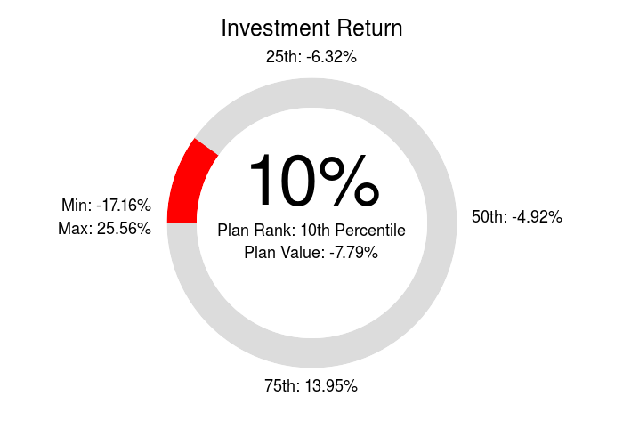

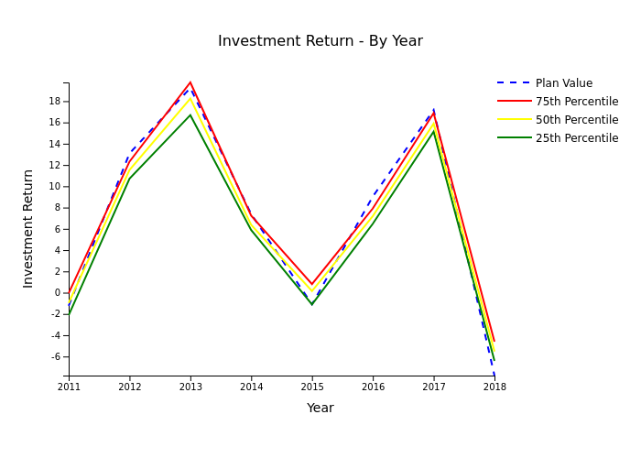

Google Llc
Google Llc 401(K) Savings Plan
Detail Operational Benchmark Results

Administrative Expense/Participant  Administrative Expense per Participant is determined by dividing the total operating expenses paid by the plan by the total active participants in the plan at the end of the year. Please note that this metric only takes into account expenses paid by the plan. It does not factor in expenses paid directly by the plan sponsor. A red gauge means that the plan rates unfavorably (high percentile score) and a green gauge means that the plan rates favorably (low percentile score) versus the peer group. This metric also displays the administrative expense per participant of the plan over the four prior years against the peer group.  A high percentile score generally indicates that the plan has higher than average expenses or that the plan sponsor pays less in plan expenses than other plan sponsors. | 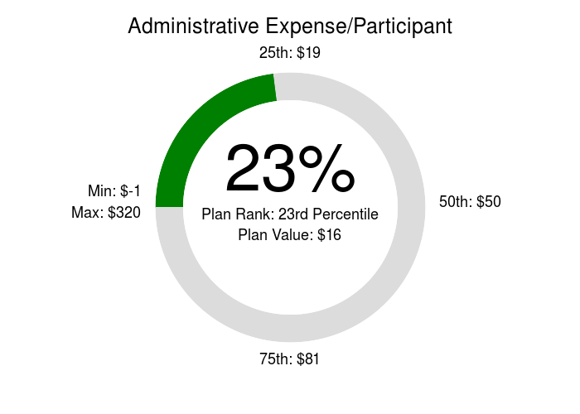

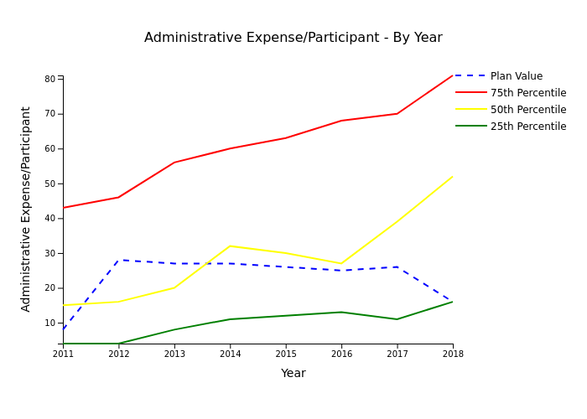

Google Llc
Google Llc 401(K) Savings Plan
Detail Operational Benchmark Results

Average Participant Contribution  Average Participant Contribution is determined by dividing the total participant contributions by the total active participants in the plan at the end of the year. A red gauge means that the plan rates unfavorably (low percentile score) and a green gauge means that the plan rates favorably (high percentile score) versus the peer group.  A high percentile score generally indicates employee satisfaction with the retirement plan. | 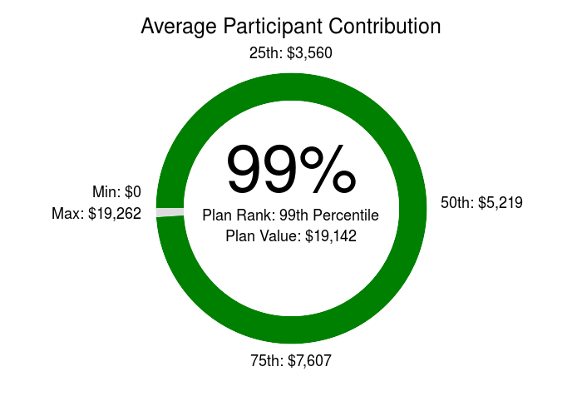

--------------------------------------------------------------------------------------------------------------------------
Average Employer Contribution  Average Employer Contribution is determined by dividing the total employer contributions by the total active participants in the plan at the end of the year. A red gauge means that the plan rates unfavorably (low percentile score) and a green gauge means that the plan rates favorably (high percentile score) versus the peer group.  A high percentile score generally indicates a strong employer commitment to the retirement security of its employees. | 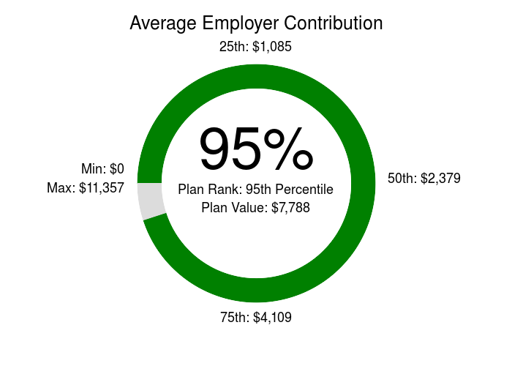

--------------------------------------------------------------------------------------------------------------------------
Participation Rate  Participation Rate is determined by dividing the active participants with an account balance by the total active participants in the plan at the end of the year. A red gauge means that the plan rates unfavorably (low percentile score) and a green gauge means that the plan rates favorably (high percentile score) versus the peer group.  A high percentile score generally indicates employee satisfaction with the retirement plan. | 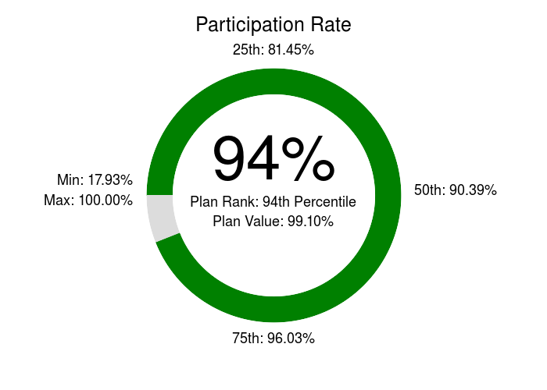

--------------------------------------------------------------------------------------------------------------------------

Google Llc
Google Llc 401(K) Savings Plan
Detail Operational Benchmark Results

Average Account Balance  Average Account Balance is determined by dividing the total assets in the plan by the total active participants in the plan at the end of the year. A red gauge means that the plan rates unfavorably (low percentile score) and a green gauge means that the plan rates favorably (high percentile score) versus the peer group.  A high percentile score generally indicates a high participation rate and/or employee longevity. | 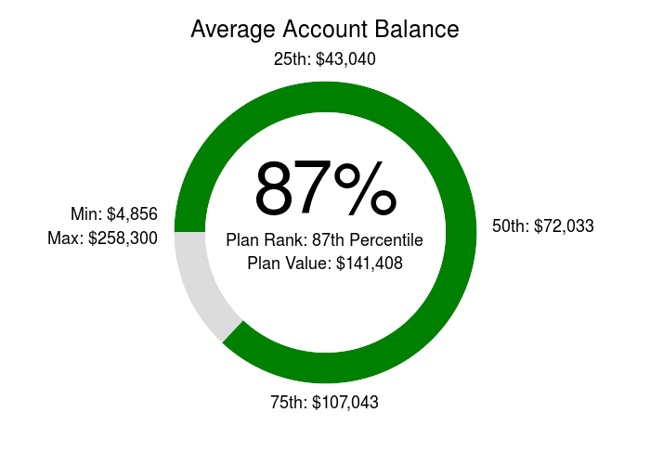

--------------------------------------------------------------------------------------------------------------------------
Average Benefit Distributions/Participant  Average Benefit Distributions per Participant is determined by dividing the total amount paid as benefits by the plan by the total active participants in the plan at the end of the year. A red gauge means that the plan rates unfavorably (high percentile score) and a green gauge means that the plan rates favorably (low percentile score) versus the peer group.  A high percentile score generally indicates a distribution of a large balance and/or high employee turnover. | 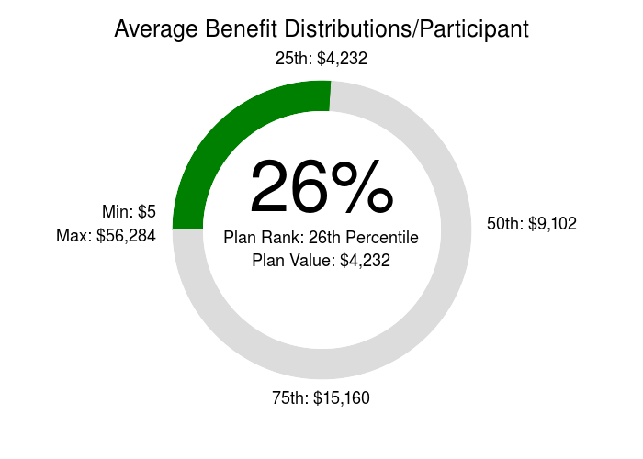

--------------------------------------------------------------------------------------------------------------------------
Corrective Distributions/Participant  Corrective Distributions per Participant is determined by dividing the total amount paid as corrective distributions by the plan by the total active participants in the plan at the end of the year. A red gauge means that the plan rates unfavorably (high percentile score) and a green gauge means that the plan rates favorably (low percentile score) versus the peer group.  A high percentile score generally indicates failed non-discrimination tests and/or forfeiture of participant loans. | 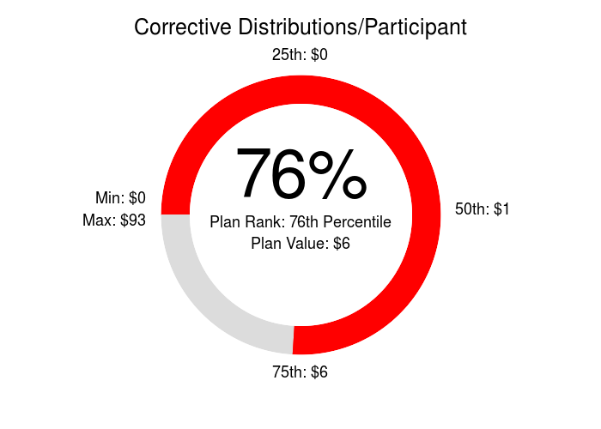

--------------------------------------------------------------------------------------------------------------------------

Google Llc
Google Llc 401(K) Savings Plan
Detail Operational Benchmark Results

Percentage of Terminated Participants  Percentage of Terminated Participants measures the extent to which account balances in the plan are held by terminated participants ("Terminated with Balances"). The percentage is calculated by dividing the number of Terminated with Balances to the total individuals with an account balance (active and terminated).  A high percentile score generally indicates a large portion of the account balances are held by terminated participants. | 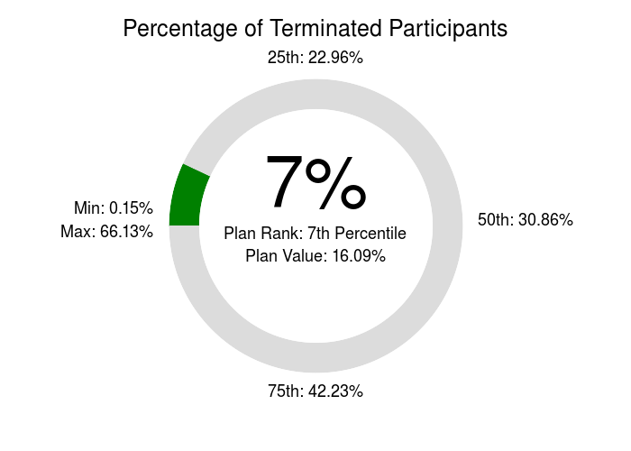

--------------------------------------------------------------------------------------------------------------------------

Google Llc
Google Llc 401(K) Savings Plan
Plan Feature Prevalence

Plan Feature Prevalence
Cross Tested Plan | Cross-testing is a sophisticated method of meeting IRS non-discrimination requirements for profit-sharing contributions. Under this testing method, current year allocations are converted to a benefit payable at retirement age. This means that allocations for younger employees will be credited with compound interest over several years while allocations for older employees will not receive the benefit of compounded interest. As a result, a cross-tested plan may allow for older business owners to receive higher profit-sharing allocations as a percentage of compensation than other, younger, employees. This feature is generally most effective when business owners are older and there are enough other younger employees. This method can also be used in larger employers with multiple divisions with disparate profit-sharing formulas that cannot utilize uniform IRS 'Safe Harbor' allocation rules.  Feature Prevalence in Peer Group (Percentage of Plans)  Yes 5.41%  No 94.59%  This Plan No
Complies with DOL sec. 404(c) | If the plan provides for participant self-direction of investments, DOL sec. 404(c) provides valuable protection to plan fiduciaries from liability for participant investment selection. Under the 404(c) rules, participants must have access to at least four investment options with carrying risk/return characteristics and must be provided with certain information about the investment options in the plan. A recent study by ERISApedia.com showed that most plans offering participant self-direction contain from 12 - 22 fund options. Most plan providers are well equipped to assist plan fiduciaries in meeting these 404(c) rules. Please note, however, that the 404(c) rules provide protection to plan fiduciaries for the participants' investment choices. The plan fiduciaries still must be prudent in the selecting the funds in the plan's investment line-up.  Feature Prevalence in Peer Group (Percentage of Plans)  Yes 87.84%  No 12.16%  This Plan Yes

Google Llc
Google Llc 401(K) Savings Plan
Plan Feature Prevalence

Plan Feature Prevalence
Participant Self-Direction | Prior to the mid 1990s most plans were operated on a 'pooled' investment basis. Each participant had an undivided interest in the underlying plan investments and plans were often only valued on a quarterly or less frequent basis. This means that participants had no say in how their 401(k) contributions were invested and would need to wait for a plan valuation in order to receive their funds after termination of employment. Employers who sponsored poled plans were hesitant to allow participants a choice in investment because the employer/fiduciary would still be liable for poor participant investment selection. All of that changed when DOL issued the 404(c) regulations (see above) which provided protection to employer/fiduciaries for participant investment selection. As a result, there are very few pooled plans left.  Feature Prevalence in Peer Group (Percentage of Plans)  Total 91.89%  Partial 4.05%  None 4.05%  This Plan Total
Matching Contributions | Employer matching contributions are contributions made on behalf of participants that are based on the amount of 401(k) contributions made by the participant. A typical formula will match a certain percentage (typically 50% - 100%) of a participant's 401(k) contributions up to a maximum amount. If the matching formula meets certain requirements, the plan will not need to undergo burdensome testing of 401(k) and matching contributions that often result in refunds to highly compensated employees. Matching contributions are an effective way to boost employee participation in the plan and to demonstrate employer concern for retirement well-being.  Feature Prevalence in Peer Group (Percentage of Plans)  Yes 93.24%  No 6.76%  This Plan Yes

Google Llc
Google Llc 401(K) Savings Plan
Plan Feature Prevalence

Plan Feature Prevalence
Plan Allows Brokerage Accounts | The most common model for participant-self direction is for the plan fiduciaries to develop and offer an investment menu of 12 - 22 funds. However, an alternative to this model is to 'open up' the investment options by providing each participant access to a brokerage account. Allowing brokerage accounts provides the greatest degree of flexibility but comes with added costs and compliance requirements. Monitoring and tracking each investment in numerous brokerage accounts can be costly and investments in certain partnerships may cause adverse tax consequences to participants. Also, the brokerage account option must essentially be offered to all participants, not just business owners. Also, allowing unsophisticated investors access to a brokerage account could be troublesome. While this can be great feature for small owner-dominated plans, this feature can lead to higher expenses and compliance issues if the plan covers a number of non-owners.  Feature Prevalence in Peer Group (Percentage of Plans)  Yes 37.84%  No 62.16%  This Plan Yes
Auto Enrollment | One of the challenges employees in the US face is saving enough for retirement. There are numerous studies that show that when faced with taking action versus taking no action, we as humans always favor inaction. In response to this human behavior, the auto enrollment feature is being promoted as a way to help ensure participants save enough for retirement. Under auto enrollment, new employees automatically contribute a percentage of pay (typically 3%) to the employer's 401(k) plan unless they affirmatively opt out. As a result, plans with auto enrollment usually have higher participation rates than plans without auto enrollment. Adding an auto enrollment feature to the plan may increase employee participation in the plan and help employees save for retirement.  Feature Prevalence in Peer Group (Percentage of Plans)  Yes 62.16%  No 37.84%  This Plan Yes

Google Llc
Google Llc 401(K) Savings Plan
Plan Feature Prevalence

Plan Feature Prevalence
Default Investment Accounts | One issue with participant self-directed plans is that participants must also select how they want their contributions to be invested. This is a particular problem with plans offering auto enrollment since participants do not need to take any action to start contributing to the plan. In the past, plan fiduciaries would pick a money market or other similar 'safe' investment as a default choice for those participants who failed to pick investments. Most financial experts agree that investing in a money market or other similar 'safe' default investment is not an effective long-term investment strategy. To allow fiduciaries to select more appropriate default investments, DOL issued regulations that provide protections for plans that offer more appropriate default investments. This feature may lower liability for plan fiduciaries when participants fail to make an election to invest their account balance.  Feature Prevalence in Peer Group (Percentage of Plans)  Yes 89.19%  No 6.76%  N/A 4.05%  This Plan Yes

